Ideation Phase
Define the Problem Statements

Date | 31 January 2025
Team ID | LTVIP2026TMIDS82253
Project Name | Deep Learning Fundus Image Analysis for Early Detection of Diabetic Retinopathy
Maximum Marks | 2 Marks

Deep Learning Fundus Image Analysis for Early Detection of Diabetic Retinopathy:

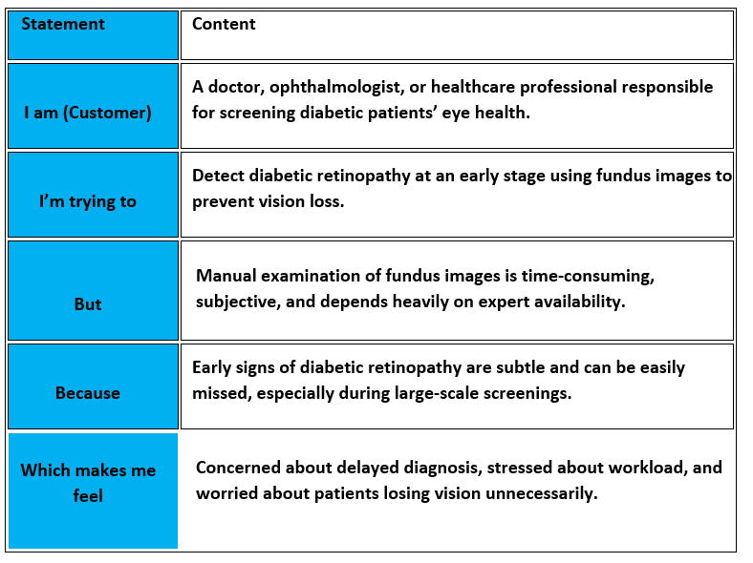

PS-1 (Doctor / Healthcare Professional View)
Element | Content
I am (doctor)
  An ophthalmologist or healthcare professional screening diabetic patients.
I’m trying to | Detect diabetic retinopathy early using fundus images.
But | Manual examination is slow and may miss early-stage symptoms.
Because | Retinal abnormalities are subtle and require expert-level attention under time pressure.
Which makes me feel | Concerned about delayed diagnosis and potential vision loss in patients.

PS-2 (Tech Developer/Team View)
Element | Content
I am | A developer working on deep-learning based medical imaging solutions.
I’m trying to | Build an accurate deep learning model to detect diabetic retinopathy from fundus images.
But | Achieving high accuracy across all disease stages is challenging.
Because | Retinal images vary in quality and labeled medical datasets are limited.
Which makes me feel | Motivated to improve healthcare outcomes using deep learning..

Project Title
Deep Learning Fundus Image Analysis for Early Detection of Diabetic Retinopathy

Problem Statement
Manual screening of fundus images for diabetic retinopathy is time-consuming, subjective, and dependent on expert availability. Early signs of the disease are often overlooked, leading to delayed diagnosis and increased risk of vision loss. There is a need for an automated and reliable screening system to support early detection.

Proposed Solution
This project uses deep learning–based convolutional neural networks (CNNs) to analyze retinal fundus images and automatically detect diabetic retinopathy. By leveraging transfer learning and image preprocessing techniques, the system aims to accurately classify disease stages and assist healthcare professionals in diagnosis.

Target Outcomes
- Achieve high classification accuracy (>90%)
- Enable early detection of diabetic retinopathy
- Reduce workload on healthcare professionals
- Support large-scale screening and telemedicine

